**BT 3074**

**Practical Sheet 06**

According to the fisheries department, a fishpond may support 250 Tilapia fish per cubic meter of space. The Tilapia fish population (in thousands) in a pond owned by the business Bluewater Fishery for the year 2022 and 2023 is shown in the following table.

|  |  |  |  |  |  |  |  |  |  |  |  |  |  |
| --- | --- | --- | --- | --- | --- | --- | --- | --- | --- | --- | --- | --- | --- |
| 2022 | Month | Jan | Feb | Mar | Apr | May | Jun | Jul | Aug | Sep | Oct | Nov | Dec |
| Population | 0.3 | 0.36 | 0.44 | 0.54 | 0.66 | 0.80 | 0.98 | 1.18 | 1.44 | 1.74 | 2.11 | 2.54 |
| 2023 | Month | Jan | Feb | Mar | Apr | May | Jun | Jul | Aug | Sep | Oct | Nov | Dec |
| Population | 3.06 | 3.67 | 4.39 | 5.23 | 6.19 | 7.29 | 8.55 | 9.94 | 11.47 | 13.12 | 14.87 | 16.7 |

1. The chosen pond has a surface area of 100 square meters and a depth of 1.5 meters. Calculate the Carrying capacity of the pond.
2. Assume that the behavior of the population growth can be described by a discrete model, write down the model.
3. Taking intrinsic growth rate as $r$, find $r$ using polyfit command.
4. Plot the predicted population vs time up to December 2026. Insert your figure.
5. If the fraction of harvesting per month is 0.42 and the growth rate is 0.4 determine the population in the reservoir in June 2025 using the following model. [for your calculation use the same initial values]
   * 1. (Eq1)

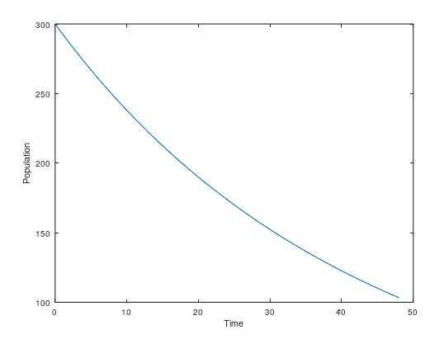

1. Discuss the behavior of the population growth using the new model.

* Change the Po, h and r and check the behavior of the graph
* Changed Po = 1000
* 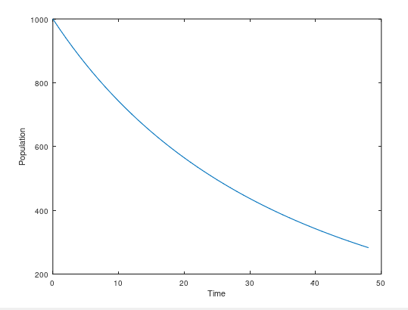
* Changed r = 0.8
* 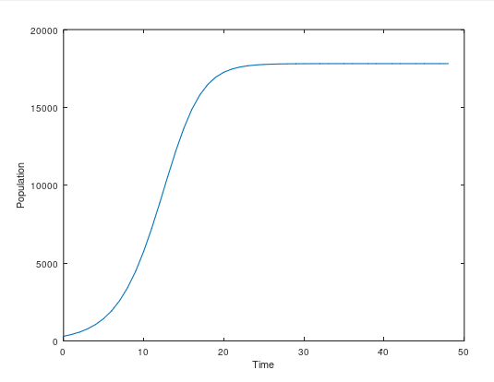
* Changed h = 0.78
* 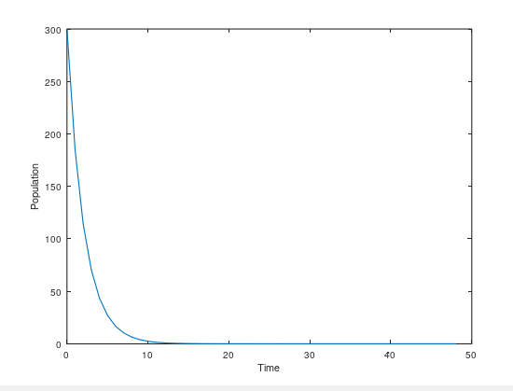
* Constant harvesting ?
* Harvesting can be increased upto 127
* 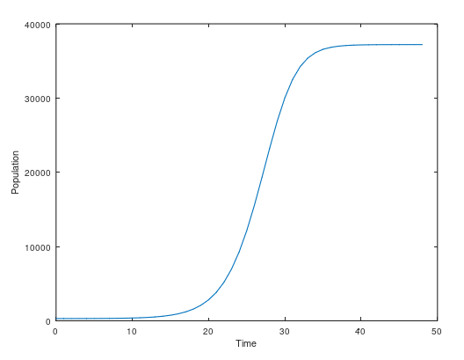

1. To increase profits, the company is supposed to maintain a fixed number of harvests per month rather than proportional harvesting (as in Eq. 1). What do you think about this?